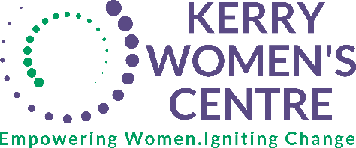

**Membership Form 2025  
  
Our Mission**Kerry Women’s Centre is an organization dedicated to engaging, educating and empowering women. Through the provision of information, support, counselling and training on issues affecting women, while encouraging respect, diversity and equality.  
**Our Goals**

* To provide the women of Kerry with education and counselling on issues which affect them, including domestic violence, post abortion counselling, women’s health and women’s rights.
* To provide women with access to information on cultural, economic, educational, health, legal, and social services.
* To coordinate and/or support projects which promote women’s equality.
* To create a space for women to meet in a place of their own to network and share information.  
  **Our Promise:**We will do all that we can for the women of our community. We will reach out and keep an open door to all women. No matter the situation, we are committed to guiding and supporting women in a non-judgemental, positive environment. Freedom is the right to stand strong and hold your head high no matter the past. We are here keeping our promise to women; we are here for you.

|  |  |
| --- | --- |
| **NAME:** |  |
| **PHONE NUMBER:** |  |
| **EMAIL ADDRESS:** |  |

**Declaration**  
I have read and agree with the mission statement of the Kerry Women’s Centre. I understand that only full members have the right to vote at General Meetings.

|  |  |
| --- | --- |
| **SIGNED:** |  |
| **DATE:** |  |

**Address:** Kerry Women’s Centre, Ráth Óraig Community Centre, 65 Ráth Óraig, Rathass, Tralee, Kerry, V92 PH32  
**Email:** [info@kerrywomenscentre.ie](mailto:info@kerrywomenscentre.ie)

**Membership Fee (please circle whichever applies/delete the one not required):**

**€15 For 6 Months €25 For One Year**

You can also pay join up and pay directly on our website: [**www.kerrywomenscentre.ie**](http://www.kerrywomenscentre.ie)